* Flat map is used for converting list of lists to a single list.
* With use of flat map we can have objects in 1D format instead of 2D format.
* It flattens an array of array to a single array.

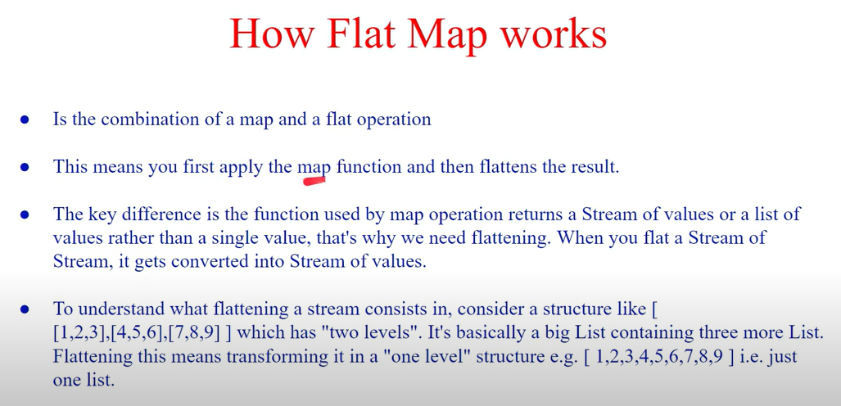

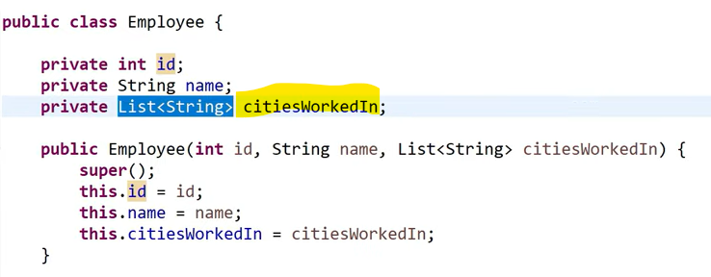

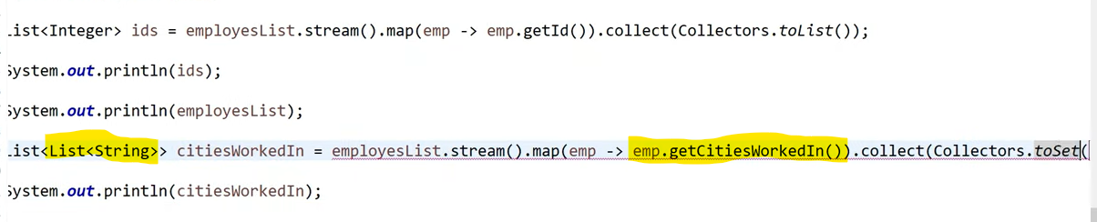

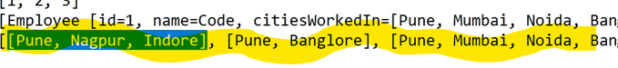

Flat map code



